**Facebook Stock Exchange**

**Introduction: -**

As we all know, Facebook ([www.Facebook.com](http://www.Facebook.com)) is one of the biggest social media website start-up by Mark Zuckerberg and his college roommates. Also, when it comes to share market, Facebook comes under top 100 most preferable companies in the world (<http://fortune.com/fortune500/facebook/>), which makes the analysis of the stock exchange an area of deep interest. The problem that we aim to address is the predictive analysis of the stock exchange volume and try to solve the problem statement which goes something like: -

“Future of the company to decide what new implementation are required for the growth of the company in next 10 years.”

**Overview of the Analysis: -**

The analysis for Facebook stock volume prediction is basically divided into two broad classes: -

1. **Qualitative Analysis**: - Includes study of various factors that affect the overall popularity of Facebook and its growth in the past few years to help us get an idea of how the stock exchange market can be influenced by these factors.
2. **Quantitative Analysis**: - This analysis includes the real time stock market data of Facebook for past 5 years which will help us study various factors in the stock market itself, affecting the stock exchange volume and finally come up with a regression model (or two) which might help us predict the future stock pricing and various other factors.

**Qualitative Analysis: -**

**Popularity of Facebook**

By Category: -

According to a report presented in August 2017 from a website called Statista ([www.statista.com](http://www.statista.com)), Facebook is the most popular social media website in the world, beating YouTube and WhatsApp with a margin of almost 500 and 800 million respectively. Following graph shows the overview of the report by Statista: -

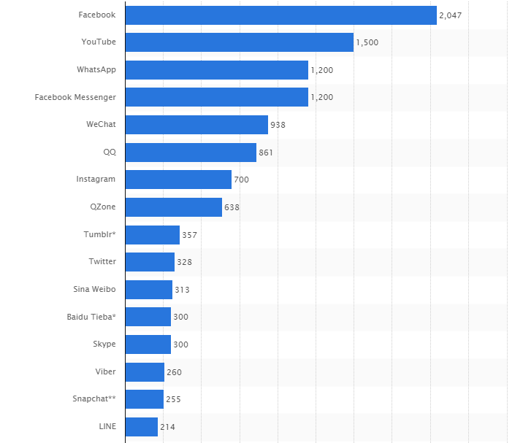

Number of active users (in millions)

According to the report, market leader Facebook was the first social network to surpass 1 billion registered accounts and currently sits at 2.05 billion monthly active users.

By Region: -

According to a report presented in June 2017 by Internet world stats (<http://www.internetworldstats.com/facebook.htm>), Asia is the number one continent which has the most number of Facebook subscribers (surpassing Europe by about 20%), which was somewhat to be expected as Asia being the largest continent in the world. A pie chart presented in the report is shown below: -

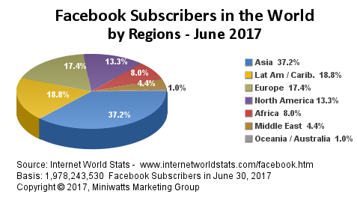

Report says that, Asia has a count of about 736 million Facebook subscribers by June 30 2017 and still counting. This research can give us an insight about which country has the most number of stock traders for Facebook.

Popularity in stock market: -

According to an article posted on Quora (<https://www.quora.com/>), following are the factors that drive the popularity of any stock in the share market:-

1. Internal Development in the company
2. World Events
3. Hype created by the company
4. Controversial activities
5. Expectations and speculations

Facebook’s biggest competitor, Snapchat may have won the market’s attention in recent months since its IPO but investors who are looking for value in technology stock are watching Facebook instead.

Factors like market capital also plays an important role while ranking a company in stock market. According to a report by a blogging website called Slate ([www.slate.com](http://www.slate.com)), Facebook comes in the top 5 largest tech company when it come to market capital.

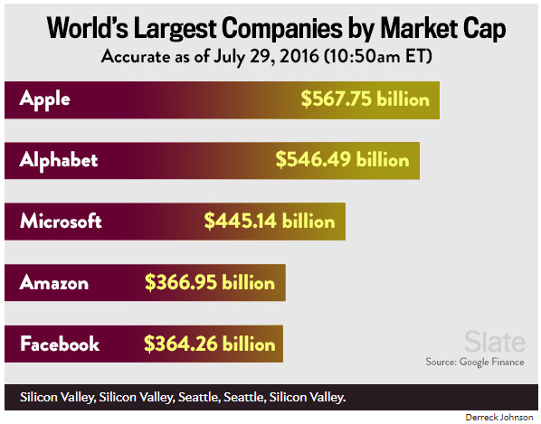

Report as of Year 2016

Facebook’s growth has also been a major factor in driving the company forward in the stock market race. Facebook’s two big guns (if we can call it like that) apart from Facebook app itself, are Facebook Messenger and WhatsApp. According to a report by a popular financial news channel CNBC, the company's stock hit an all-time intraday high, up more than 1 percent at $121.92. WhatsApp is another big tech application for socializing and Facebook did a fantastic job in buying the company in 2014. WhatsApp’s new features continues to amaze its audience and increase popularity all over the world.

**Quantitative Analysis: -**

After studying various factors that can affect the popularity of the company, next comes the quantitative aspect where we focus on developing a regression model to get some predictions on the future data that is going to be there.

For doing the regression analysis, we took data from the real stock market world (<https://finance.yahoo.com>), which provide us with the stock market history of past five years (31Aug 2012 - 31Aug 2017). Now on reading of data, following were the observation:-

Data-set contains nine parameters, namely:

**Opening stock price(open)**, **Highest stock price(High)**, **Low stock price(Low)**, Closing stock price(close), Adjusted closing stock price(Adj. Close), **Stock exchange volume(volume)**, year of the stock market(year), Month of stock market(month), Day of the stock market w.r.t the initial day(day).

Now, after observing these parameters, we can see by intuition that our stock exchange volume (that is nothing but number of trades happening in a day) should depend heavily on the opening price, the highest price and lowest stock price. Our task is to see if there is a (if any) correlation between these variables with our desired stock exchange volume variable.

**Getting the summary statistics: -**

Summary stats. is a very effective way of getting an idea of how an entity is changing over any particular interval(in this case we are looking over time). Following is the summary statistics that we get: -

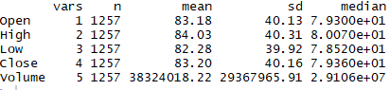

Summary Statistics

Now, as we can see that the mean value of opening stock price is $84.18, which is pretty much high, showing us that company has “big money”. Also the average stock exchange volume is around 38 million stock trades which is a pretty good measure. But are these numbers enough? To answer this question, plotting some data in a graphical form might help.

**Data Visualization: -**

First plotting the Stock exchange volume to gain some insights:-

As we can see, the stock trade volume is decreasing as the days go by, now we have to analyse what are the factors that are responsible for this decline.

Few more plotting to give us more insights:-

Plotting Opening stock price over time:-

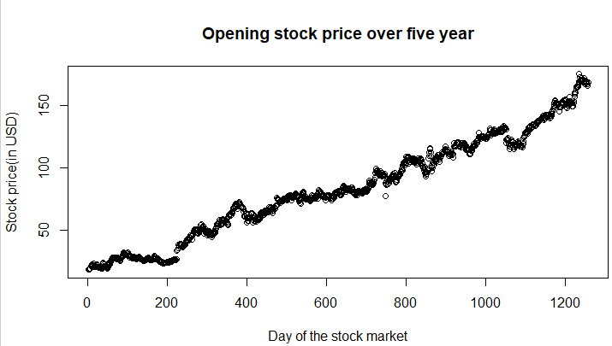

As we can observe that opening stock price increase almost linearly with time giving us the idea about the continuous company growth.

Plotting Highest stock price VS Time, we get:-

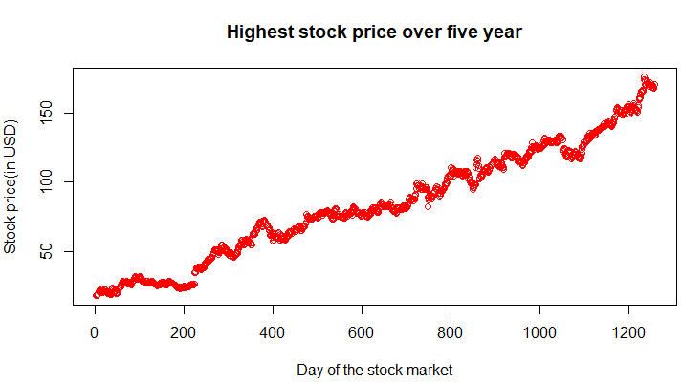

Same as above, the demand for the stocks of Facebook has increased manifold, and to meet this demand, stock prices are bound to shoot up.

Scatter plots for finding correlations:-

Scatter plots are the best and the easiest way to find whether and how (if correlated) two variables are correlated to each other. Following is a row wise depiction of the scatter plots: -

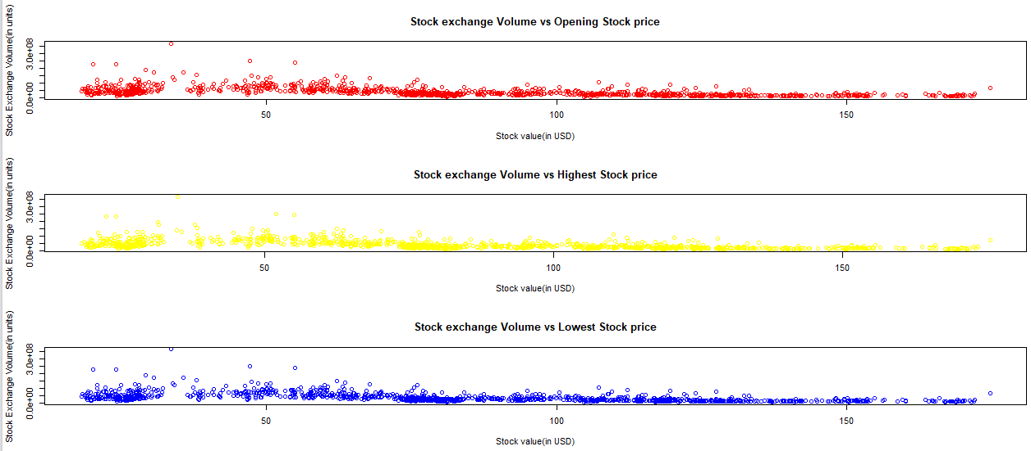

As we can visually observe that ,as we go forward in time, the stock exchange volume and all the parameters related to it are negatively correlated. Now this is only our assumption, and based on this we will propose some hypothesis.

Hypothesis 1: *As the sum of the three quantities increases, stock volume exchange decreases.*

Now our task is narrowed down to test this hypothesis.

**Testing of Hypothesis:-**

In order to test the hypothesis, we ran some t-tests, correlation tests, plotted correlation-plot matrix etc.

Following is the correlation matrix that showed us some important insights:-

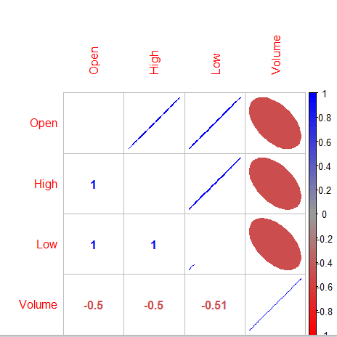

Correlation-plot matrix

As we can see clearly here, the stock exchange volume and the Lowest stock price are the most correlated entities which gives us an idea that indeed higher the low price, lower will be the number of trades that will be there on a particular day.

As from other tests, we get that the hypothesis stands correct (p-values of all the sets came out to be less than 0.05).

**Model:-**

Finally, developing a regression model for our tested hypothesis, we found out following results:-

1. The confidence interval in the model was low (42.64%).
2. According to the model, stock volume exchange will keep on decreasing, which should not be case.

**Real-time Model Testing: -**

Taking the real time data that is after 31st Aug 2017 and testing against our model yields following results:-

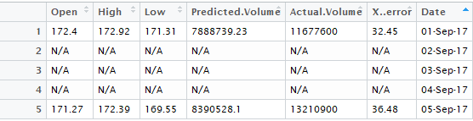

Table depicting the predicted data versus real time data of Stock Exchange Volume

**Conclusion: -**

The main motivation behind this regressive analysis of Facebook stock exchange was to get an idea of how things move around for a big company like Facebook in the marketing world.

Although, our model came out to be not that much accurate, we can still conclude very useful insights and possibly future improvement of the model.

**Scope of Improvement: -**

Following can be the ways by which we can make a more regressed and accurate model:-

1. Taking more variables into account will give us more exposure to the data and can possibly (not necessarily) help us come up with a more accurate model.
2. Non-linear regression analysis can help us getting more accurate results as we all know that in reality, nothing follows a line. In a case like capturing the future for Facebook stock exchange, non-linear analysis will help us gain more insights.

**References:-**

**Facebook popularity worldwide data:-**

<http://www.internetworldstats.com/facebook.htm>

**Facebook popularity w.r.t social media website:-**

<https://www.statista.com/statistics/272014/global-social-networks-ranked-by-number-of-users/>

**Growth report of Facebook:-**

<https://investorplace.com/2017/07/instagram-facebook-inc-fb-stock-growth/#.Wa_dE8gjHIV>

<https://investorplace.com/2017/05/trade-facebook-inc-fb-stock-for-900-profits/#.Wa_gFsgjHIV>

**Factors affecting popularity of company in stock market:-**

<https://www.quora.com/What-are-the-factors-affecting-share-price>

**Market Capital report of Facebook:-**

<http://www.slate.com/blogs/moneybox/2016/07/29/the_world_s_5_most_valuable_companies_apple_google_microsoft_amazon_facebook.html>

**Facebook’s two most powerful guns (Facebook Messenger and** **WhatsApp) report:-**

<https://www.cnbc.com/2016/07/20/facebook-stock-hits-an-all-time-high-as-messenger-announces-1-billion-users.html>

**Non-Linear Regression Analysis:-**

<https://en.wikipedia.org/wiki/Nonlinear_regression>